Introduction

What is a Servlet ?
What does a Servlet do ?
Why do we need Servlets ?

Servlet → is a java class
to be servlet → a class extends from “HttpServlet”

What do servlet can do?
Manipulate requests and generate suitable response
Identify the methods come with request → execute the suitable toMethod for receiving method → generate suitable response → and resend

Situations that we need Servlet?
When need to generate content dyamically
when need to do changes in server side

Example:- we need to save customers in web applications but it cannot be done only using html, css, js because of it is on frond end(client’s machine). So need to serve in backend side

----------------------------------------------------------------------------------------------------------------
annotations/ decorators
annotation means → metadata → extra information
@WebServlet
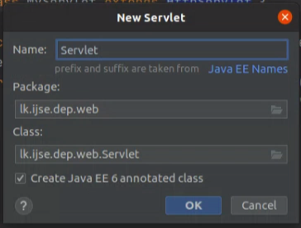

to get this annotation, need to mark this “create java EE 6 annotated class”

attributes/ elements

urlPatterns represents → for which urls that Servlet shoud work

servletName → servlet is identified by this name in whole app

loadOnStartup →
normally object is created (initiate of instance methods) from servlet when first request is come to this url

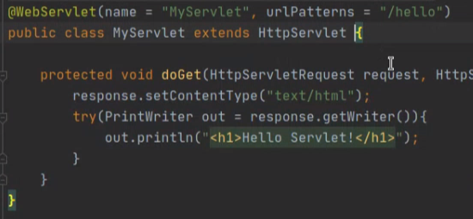

Inerview
Class hierachy – http servlet ?
Servlet (interface) ← Generic servlet (abstract class)← HttpServlet (class)

in the java EE context, web component → servlet jsp

servlet has a lifecycle like a object (the time of object create and destroy)
main states of any servlet → init, service, destroy

servlet configuration object is special for every servlet

generic servelt – has two init methods

continue here on……...

----------------------------------------------------------------------------------------

1. first check configurations available in DD(web.xml)
2. check servlet that match to utl
3. that servlet class is load to ram
4. create servlet object

Tomcat is created two objects → HttpServletRequest, HttpServletResponse
Tomcat has that two object references

exact mapping
wildcard mapping
extension mapping
not starting from “/”

Front control – design pattern
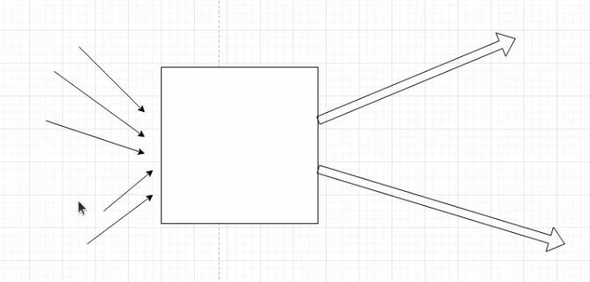
all requests are come to one servlet then dispatch(like distribute) to objects

